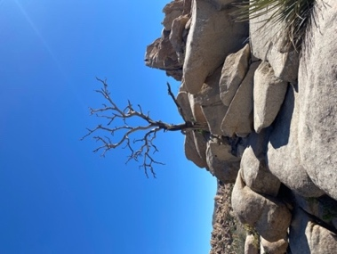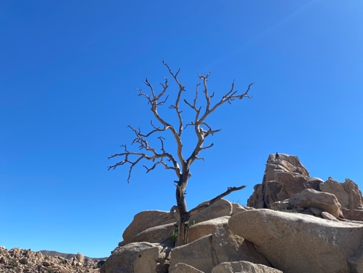

Crossroads Conversations: End-of-Life Hopes, Fears, & Curiosities

Saturday, July 12, 2:30-4:00pm

What happens—physically, spiritually—when we die? How can I be more prepared for, and less fearful of, this natural life event? What practical things do I need to know when my loved one dies? How can I avoid being overwhelmed by grief?

Crossroads Conversations provides a comfortable space in which to explore your hopes, fears, and questions related to death. Although our culture conditions us to be fearful, end of life can be a time of clarity about what is important and other deeply meaningful personal and spiritual lessons. Contemplating our own impermanence can help us to live more consciously. This discussion group has no agenda, no planned presentation, and no prerequisite other than being a mortal human. Simply come as you are to join a relaxed community conversation about a profound topic that is relevant to all of us.

Registration is not required, but it is helpful. If you plan to attend, please send an email to the facilitator at Michael.PresentPurpose@gmail.com. If you have a question—about the event or that you hope to discuss at the event—reach out to him. Or simply show up.

Michael Sala has been a wellness, care, and support professional for over 30 years. As a special education and later hospice social worker, he has served individuals from age 4 to 104. Now retired from social work, he offers a holistic array of services for wellbeing throughout life and at end of life, including end-of-life care as a death midwife, spiritual guidance, Thai bodywork, and yoga classes. He is also a poetry enthusiast and a proponent of radical unconditional love. Learn more about his offerings at presentpurpose.weebly.com and imagineabetterfuture.weebly.com.

